- Install following extensions in VS Code:
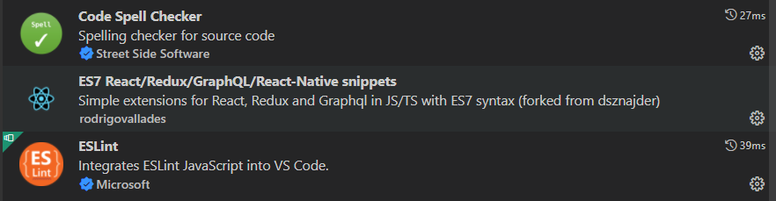
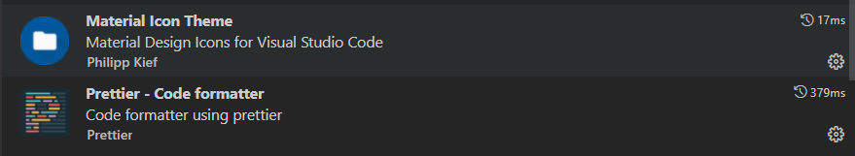
- Once the react project has been created install following dependenices:
npm install -D eslint prettier eslint-config-prettier
- npx eslint --init
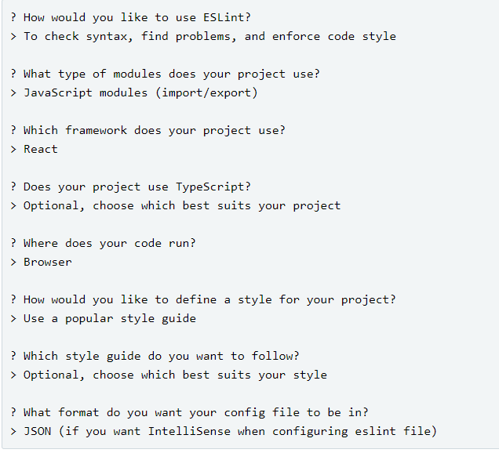
- Restart your VS code and now you would see error lines. Goto eslintrc.js file and add prettier
Also add the following rule which allows to write JSX code in .js files
'react/jsx-filename-extension': [1, { extensions: ['.js', '.jsx'] }],
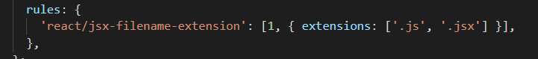
Also add following rule:
'import/prefer-default-export': 'off',
- Create a .prettierrc.json file at the root of your project and add some configurations to it. Feel free to customize it with your preferences.
{
"semi": true,
"singleQuote": true,
"trailingComma": "es5",
"arrowParens": "avoid",
"endOfLine": "lf"
}
- Press Cntrl+Shift+P and select 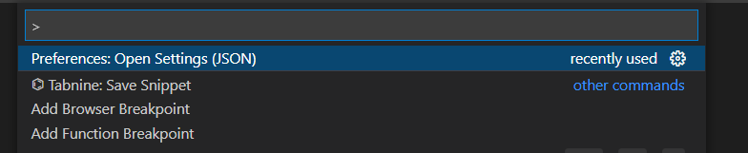
Now add the following lines:
{
"editor.formatOnSave": true,
"editor.defaultFormatter": "esbenp.prettier-vscode"
}

- Restart your VS code.

